The Way of the Cross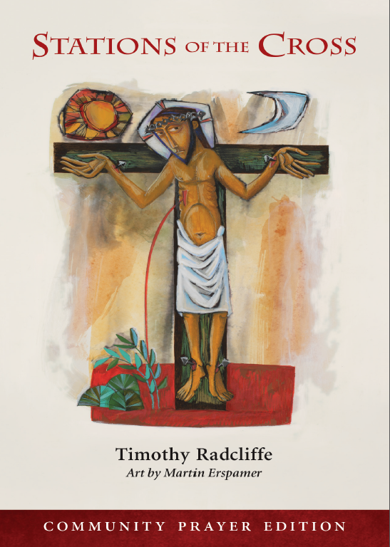

Stations of the Cross – Online Service
Wednesday, April 16th 2025
7:00 p.m.

The Book of Alternative Services (BAS) and Common Praise (CP)

The Way of the Cross

Leader: In the name of the Father, and of the Son, and of the Holy
Spirit
All: Amen.

Leader: Lord, have mercy.
All: Christ, have mercy.

Leader: Lord, have mercy.

Leader: We will glory in the cross of our Lord Jesus Christ:
All: In whom is our salvation, our life and resurrection.

Leader: Let us pray.

(Silence may be kept)

All: Assist us mercifully with your help, O Lord
God of our salvation, that we may enter with joy upon the contemplation of those mighty acts, whereby you have given us life and immortality; through Jesus Christ our Lord. Amen.

All gather at the First Station

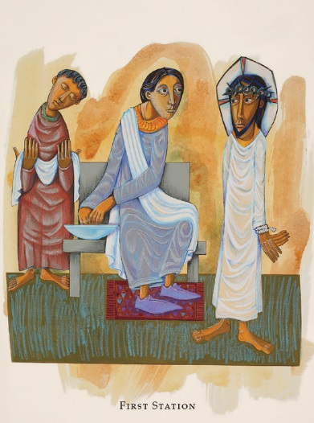
First Station ~ Jesus is condemned to death

1st Station Reader: Marcia Winterbottom

We adore you, O Christ, and we bless you:
Because by your holy cross you have redeemed the world.

As soon as it was morning, the chief priests, with the elders and scribes, and the whole council, held a consultation; and they bound Jesus and led him away and delivered him to Pilate. And they all condemned him and said, “He deserves to die.” When Pilate heard these words, he brought Jesus out and sat down on the judgment seat at a place called the Pavement, but in the Hebrew, Gabbatha. Then he handed Jesus over to them to be crucified.

God did not spare his own Son:
But delivered him up for us all.

Let us pray. (Silence)

Almighty God, whose most dear Son went not up to joy but first he suffered pain, and entered not into glory before he was crucified: Mercifully grant that we, walking in the way of the cross, may find it none other than the way of life and peace; through Jesus Christ your Son our Lord. Amen.

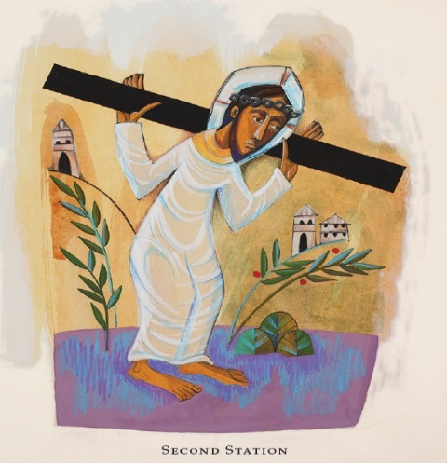
Second Station ~ Jesus takes up his Cross

2nd Station Reader: Margaret Warren

We adore you, O Christ, and we bless you:
Because by your holy cross you have redeemed the world.

Jesus went out, bearing his own cross, to the place called the place of a skull, which is called in Hebrew, Golgotha. Although he was a Son, he learned obedience through what he suffered. Like a lamb he was led to the slaughter; and like a sheep that before its shearers is mute, so he opened not his mouth. Worthy is the Lamb who was slain, to receive power and riches and wisdom and strength and honour and glory and blessing.

The Lord has laid on him the iniquity of us all:
For the transgression of my people was he stricken.

Let us pray. (Silence)

Almighty God, whose beloved Son willingly endured the agony and shame of the cross for our redemption: Give us courage to take up our cross and follow him; who lives and reigns for ever and ever. Amen.

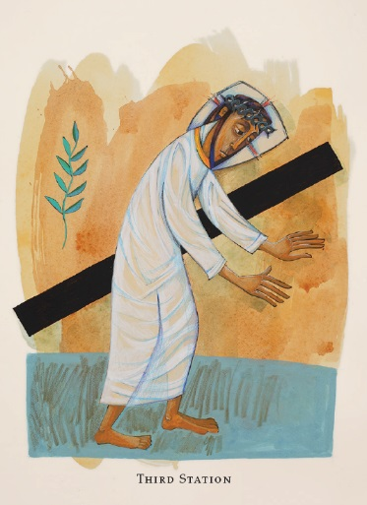
Third Station ~ Jesus falls the first time

3rd Station Reader: Mary Larson

We adore you, O Christ, and we bless you:
Because by your holy cross you have redeemed the world.

Christ Jesus, though he was in the form of God, did not count equality with God a thing to be grasped; but emptied himself, taking the form of a servant, and was born in human likeness. And being found in human form he humbled himself and became obedient unto death, even death on a cross. Therefore God has highly exalted him, and bestowed on him the name which is above every name. Come, let us bow down, and bend the knee, and kneel before the Lord our Maker, for he is the Lord our God.

Surely he has borne our griefs:
And carried our sorrows.

Let us pray. (Silence)

O God, you know us to be set in the midst of so many and great dangers, that by reason of the frailty of our nature we cannot always stand upright: Grant us such strength and protection as may support us in all dangers, and carry us through all temptations; through Jesus Christ our Lord. Amen.

Music: Jesus, Remember Me
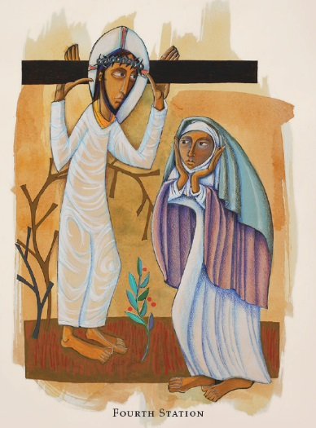
Fourth Station ~ Jesus meets his afflicted mother

4th Station Reader: Joyce Mattis

We adore you, O Christ, and we bless you:
Because by your holy cross you have redeemed the world.

To what can I liken you, to what can I compare you, O daughter of Jerusalem? What likeness can I use to comfort you, O virgin daughter of Zion? For vast as the sea is your ruin. Blessed are those who mourn, for they shall be comforted. The Lord will be your everlasting light, and your days of mourning shall be ended.

A sword will pierce your own soul also:
And fill your heart with bitter pain.

Let us pray. (Silence)

O God, who willed that in the passion of your Son a sword of grief should pierce the soul of the Blessed Virgin Mary his mother: Mercifully grant that your Church, having shared with her in his passion, may be made worthy to share in the joys of his resurrection; who lives and reigns for ever and ever. Amen.

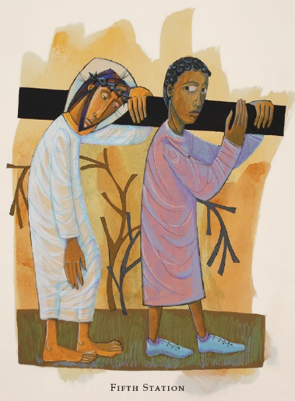
Fifth Station ~ The Cross is laid on Simon of Cyrene

5th Station Reader: Norma Tutty

We adore you, O Christ, and we bless you:
Because by your holy cross you have redeemed the world.

As they led Jesus away, they came upon a man of Cyrene, Simon by name, who was coming in from the country, and laid on him the cross to carry it behind Jesus. “If anyone would come after me, let him deny himself and take up his cross and follow me. Take my yoke upon you, and learn from me; for my yoke is easy, and my burden is light.”

Whoever does not bear his own cross and come after me:
Cannot be my disciple.

Let us pray. (Silence)

Heavenly Father, whose blessed Son came not to be served but to serve: Bless all who, following in his steps, give themselves to the service of others; that with wisdom, patience, and courage, they may minister in his Name to the suffering, the friendless, and the needy; for the love of him who laid down his life for us, your Son our Savior Jesus Christ. Amen.

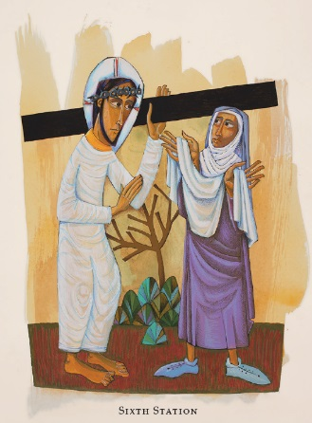
Sixth Station ~ A woman wipes the face of Jesus

6th Station Reader: Blanchard Raveendraraj

We adore you, O Christ, and we bless you:
Because by your holy cross you have redeemed the world.

We have seen him without beauty or majesty, with no looks to attract our eyes. He was despised and rejected by men; a man of sorrows, and acquainted with grief; and as one from whom men hide their faces, he was despised, and we esteemed him not. His appearance was so marred, beyond human semblance, and his form beyond that of the children of men. But he was wounded for our transgressions, he was bruised for our iniquities; upon him was the chastisement that made us whole, and with his stripes we are healed.

Restore us, O Lord God of hosts:
Show the light of your countenance, and we shall be saved.

Let us pray. (Silence)

O God, who before the passion of your only-begotten Son revealed his glory upon the holy mountain: Grant to us that we, beholding by faith the light of his countenance, may be strengthened to bear our cross, and be changed into his likeness from glory to glory; through Jesus Christ our Lord. Amen.

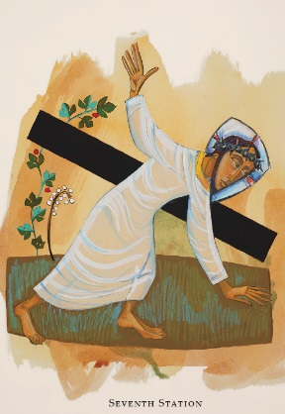
Seventh Station ~ Jesus falls a second time

7th Station Reader: Veronica Johnson

We adore you, O Christ, and we bless you:
Because by your holy cross you have redeemed the world.

Surely he has borne our griefs and carried our sorrows. All we like sheep have gone astray; we have turned every one to his own way; and the Lord has laid on him the iniquity of us all. He was oppressed, and he was afflicted, yet he opened not his mouth. For the transgression of my people was he stricken.

But as for me, I am a worm and no man:
Scorned by all and despised by the people.

Let us pray. (Silence)

Almighty and everliving God, in your tender love for the human race you sent your Son our Savior Jesus Christ to take upon him our nature, and to suffer death upon the cross, giving us the example of his great humility: Mercifully grant that we may walk in the way of his suffering, and also share in his resurrection; who lives and reigns for ever and ever. Amen.

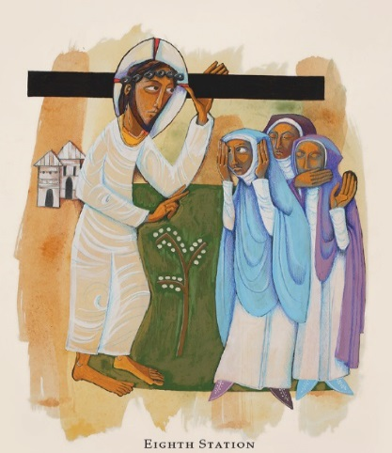
Eighth Station ~ Jesus meets the women of Jerusalem

8th Station Reader: Rhyll Simic

We adore you, O Christ, and we bless you:
Because by your holy cross you have redeemed the world.

There followed after Jesus a great multitude of the people, and among them were women who bewailed and lamented him. But Jesus turning to them said, “Daughters of Jerusalem, do not weep for me, but weep for yourselves and for your children.”

Those who sowed with tears:
Will reap with songs of joy.

Let us pray. (Silence)

Teach your Church, O Lord, to mourn the sins of which it is guilty, and to repent and forsake them; that, by your pardoning grace, the results of our iniquities may not be visited upon our children and our children’s children; through Jesus Christ our Lord. Amen.

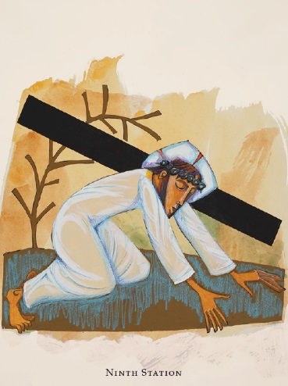
Ninth Station ~ Jesus falls a third time

9th Station Reader: Marion Jack

We adore you, O Christ, and we bless you:
Because by your holy cross you have redeemed the world.

I am the man who has seen affliction under the rod of his wrath; he has driven and brought me into darkness without any light. He has besieged me and enveloped me with bitterness and tribulation; he has made me dwell in darkness like the dead of long ago. Though I call and cry for help, he shuts out my prayer. He has made my teeth grind on gravel, and made me cower in ashes. “Remember, O Lord, my affliction and bitterness, the wormwood and the gall!”

He was led like a lamb to the slaughter:
And like a sheep that before its shearers is mute, so he opened not his mouth.

Let us pray. (Silence)

O God, by the passion of your blessed Son you made an instrument of shameful death to be for us the means of life: Grant us so to glory in the cross of Christ, that we may gladly suffer shame and loss for the sake of your Son our Savior Jesus Christ. Amen.
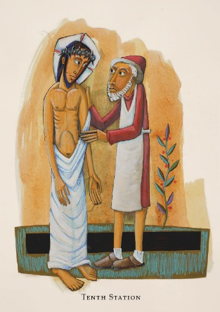
Tenth Station ~ Jesus is stripped of his garments

10th Station Reader: Dorothy Gurney

We adore you, O Christ, and we bless you:
Because by your holy cross you have redeemed the world.

When they came to a place called Golgotha (which means the place of a skull), they offered him wine to drink, mingled with gall; but when he tasted it, he would not drink it. And they divided his garments among them by casting lots. This was to fulfill the scripture which says, “They divided my garments among them; they cast lots for my clothing.”

They gave me gall to eat:
And when I was thirsty they gave me vinegar to drink.

Let us pray. (Silence)

Lord God, whose blessed Son our Savior gave his body to be whipped and his face to be spit upon: Give us grace to accept joyfully the sufferings of the present time, confident of the glory that shall be revealed; through Jesus Christ our Lord. Amen.

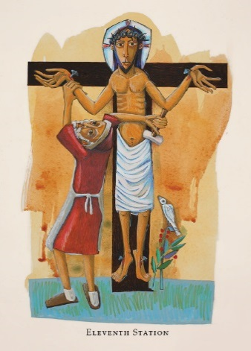
Eleventh Station ~ Jesus is nailed to the Cross

11th Station Reader: Ninian Bacchus

We adore you, O Christ, and we bless you:
Because by your holy cross you have redeemed the world.

When they came to the place which is called The Skull, there they crucified him; and with him they crucified two criminals, one on the right, the other on the left, and Jesus between them. And the scripture was fulfilled which says, “He was numbered with the transgressors.”

They pierce my hands and my feet:
They stare and gloat over me.

Let us pray. (Silence)

Lord Jesus Christ, you stretched out your arms of love on the hard wood of the cross that everyone might come within the reach of your saving embrace: So clothe us in your Spirit that we, reaching forth our hands in love, may bring those who do not know you to the knowledge and love of you; for the honour of your Name. Amen.

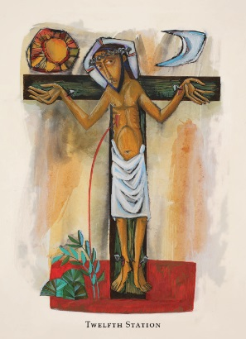
Twelfth Station ~ Jesus dies on the Cross

12th Station Reader: Claudette Bonnie

We adore you, O Christ, and we bless you:
Because by your holy cross you have redeemed the world.

When Jesus saw his mother, and the disciple whom he loved standing near, he said to his mother, “Woman, behold your son!” Then he said to the disciple, “Behold your mother!” And when Jesus had received the vinegar, he said, “It is finished!” And then, crying with a loud voice, he said, “Father, into your hands I commend my spirit.” And he bowed his head, and handed over his spirit.

Christ for us became obedient unto death:
Even death on a cross.

Let us pray. (Silence)

O God, who for our redemption gave your only-begotten Son to the death of the cross, and by his glorious resurrection delivered us from the power of our enemy: Grant us so to die daily to sin, that we may evermore live with him in the joy of his resurrection; who lives and reigns now and for ever. Amen.

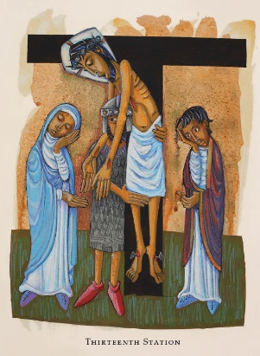
Thirteenth Station ~ Jesus’ body is placed in the arms of his mother

13th Station Reader: Ose Ibazebo

We adore you, O Christ, and we bless you:
Because by your holy cross you have redeemed the world.

All you who pass by, behold and see if there is any sorrow like my sorrow. My eyes are spent with weeping; my soul is in tumult; my heart is poured out in grief because of the downfall of my people. “Do not call me Naomi (which means Pleasant), call me Mara (which means Bitter); for the Almighty has dealt very bitterly with me.”

Her tears run down her cheeks:
And she has none to comfort her.

Let us pray. (Silence)

Lord Jesus Christ, by your death you took away the sting of death: Grant to us your servants so to follow in faith where you have led the way, that we may at length fall asleep peacefully in you and wake up in your likeness; for your tender mercies’ sake. Amen.

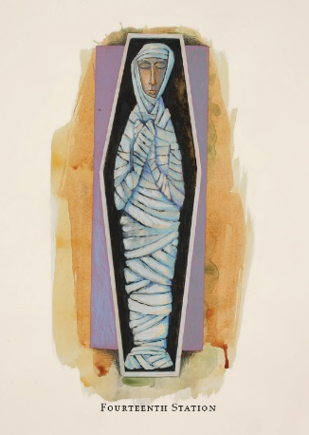
Fourteenth Station ~ Jesus is laid in the tomb

14th Station Reader: Trevor Matthew

We adore you, O Christ, and we bless you:
Because by your holy cross you have redeemed the world.

When it was evening, there came a rich man from Arimathea, named Joseph, who also was a disciple of Jesus. He went to Pilate and asked for the body of Jesus. Then Pilate ordered it to be given to him. And Joseph took the body, and wrapped it in a clean linen shroud, and laid it in his own new tomb, which he had hewn in the rock; and he rolled a great stone to the door of the tomb.

You will not abandon me to the grave:
Nor let your holy One see corruption.

Let us pray. (Silence)

O God, your blessed Son was laid in a tomb in a garden, and rested on the Sabbath day: Grant that we who have been buried with him in the waters of baptism may find our perfect rest in his eternal and glorious kingdom; where he lives and reigns for ever and ever. Amen.

CONCLUDING PRAYERS BEFORE THE ALTAR

Celebrant: Savior of the world, by your cross and precious blood you have
redeemed us:
Save us, and help us, we humbly beseech you, O Lord.

Let us pray. (Silence)

We thank you, heavenly Father, that you have delivered us from the dominion of sin and death and brought us into the kingdom of your Son; and we pray that, as by his death he has recalled us to life, so by his love he may raise us to eternal joys; who lives and reigns with you, in the unity of the Holy Spirit, one God, now and for ever. Amen.

To Christ our Lord who loves us, and washed us in his own blood, and made us a kingdom of priests to serve his God and Father, to him be glory and dominion for ever and ever. Amen.

